Strawberry Shortsword Battle System

# Overview

In mobile RPG *Strawberry Shortsword*, players take part in **turn-based combat**, controlling a player character’s actions using **action commands** to defeat enemies. The visual layout and controls/interface are heavily inspired by the *Mario & Luigi* RPG series, but action commands are designed for **smartphone inputs**, using touch-screen taps and drags, gyro motion detection, and microphone audio detection.

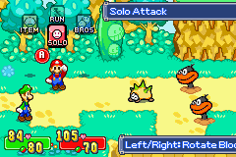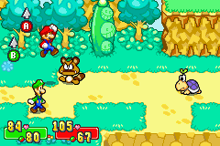

# Flow of Battle

## Battle Openings

A battle begins with a **transitionary visual effect** (such as a fade in from black) that reveals the battle scene, populated with **the player character to the left** of the screen facing one or more **enemies to the right** of the screen, all set against a **background floor and wall image**. **Characters play any initial animations** they may have as the battle begins, such as the player character unsheathing their weapon or a monster growling. At the same time, general UI elements such as **player and enemy HP numbers animate into view**.

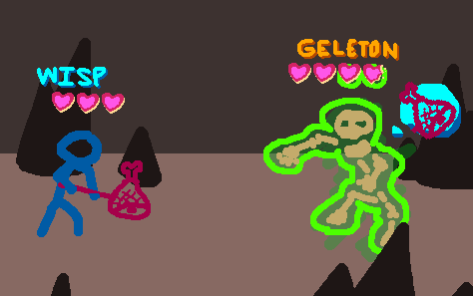

## Player Turn

### Item Usage

*Gotta put somethin’ here about how you can open an inventory UI to look through and use items on your turn. Probably only get to use one item per turn alongside your one action (and have to use the item first because using an action ends your turn), but can also set an item as your reaction item for defending on enemy turns?*

### Action Choice

Battles typically begin with the player taking a turn. On a player’s turn, **action choice buttons** **appear** **around both the player character** (in the case of actions meant to be used on themselves such as to heal or buff their attacks) **and around enemies** (in the case of actions mean to target them with attacks or negative effects). These buttons present icons depicting what action they represent. **Once an action choice button is tapped, all action choice buttons disappear** and the **background goes dark** and **play moves into the** **action command phase**.

### Action Commands

During this phase, **on-screen visuals related to the chosen action will appear** to indicate to the player what kind of inputs they should perform to successfully use their chosen action command, and **how well they perform these inputs determines the results** of their action. For instance, after choosing to attack a geleton enemy with a black forest hammer, players will see UI visuals and text prompting them to touch and swipe on the screen in a certain direction, hold their finger or thumb there for a moment, and then release their touch with specific timing. If the player performs these action command inputs accurately and with correct timing, their player character will enact the associated action, in this case dashing toward the geleton and swinging down their hammer to deal them damage accompanied by visual effects and damage number UI before returning to the left side of the screen. **Whether successful or not, UI text will appear to give the player feedback on their inputs**, giving simple tips on improving with text like “too quick!” or “tilt more!” when there’s room for improvement or “perfect!” when done just right. After an action command is complete, the **background becomes lit** once more and the **player’s turn will end, moving the game into the enemies’ turns**.

## Enemy Turns

### Enemy Action

**Enemies will each take a turn of their own in a set order**. On an enemy’s turn, they will choose to take an action they’re capable of, most often one in which they will attack a player. Enemies’ actions will be accompanied by relevant animations of them moving around, using items, launch attacks, and so forth, and **in many cases these actions give players the chance to respond with inputs using a reaction command** in the middle of the enemy’s turn. Attacking enemies typically use animations to telegraph their attacks as clues to help players defend themselves with reaction commands. **When an enemy’s action ends, their turn is over**. The **next enemy who hasn’t taken a turn yet does so** now, **and if there are none left who haven’t done so, the player begins their next turn**.

### Reaction Commands

*Probably somethin’ about buttons and UI for inputs that show up only during enemy actions, and you do them to use items or defend yourself. Do reaction commands use your weapon, or only other items, like smoke bombs or shields and whatnot? Do you have to start a reaction command by pressing a button for which item to use in the reaction and then do inputs for it, like tapping the button for a smoke bomb and then having to swipe down to throw it at your feet? Or can the initial choice of reaction item be done earlier, during your own turn, where you set an item as your reaction (perhaps by dragging it out of your inventory list and onto a “reaction slot” UI element), and then if it’s applicable during an enemy’s action, you just get to do the input for it straightaway? That may be better because it’s one less input when the enemy’s going.*

## Battle Endings

*Somethin’ about fights ending when you or all the baddies are KOd, with a blurb on each and results.*